**COMPUTER SCIENCE AND ENGINEERING**

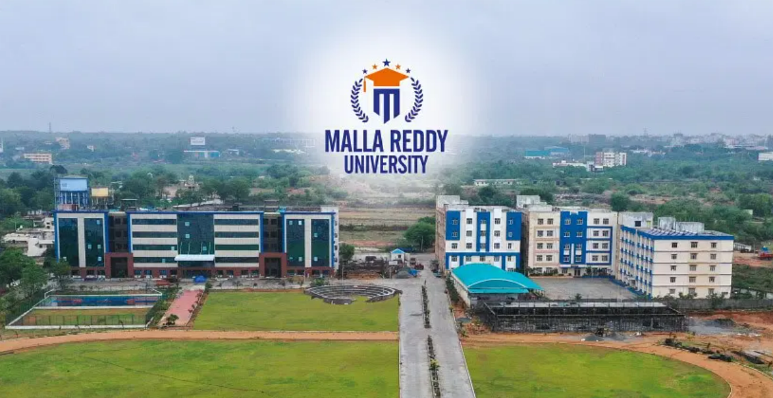

2023-2024

Instructor:   
Dr. Shazia Khan



English for Technical Communication and Employability Skills

CSE(Group-7A)-2211CS010487

Akshay Rachakonda

**MALLA REDDY UNIVERISTY, HYDERABAD**